PIP

Document Change Control
V1.0 Creation Date 07/28/10 Original Author: Mike Corbin

Objective
Provide forms for users to enter productivity improvement projects.

Requirements
The requirements for this application have evolved with the application over its lifecycle.

Assumptions
Application must be available to all users within US and Europe. Training must be completed for all users that will utilize the application.

Issues
Loss of connectivity to Web application will halt entire process and back-up plan must be developed.

Security
Everyone can enter a project and view all other projects. Only the user that entered a project, or the Project Owner for that project can update it.

Detailed Design
There are 2 pages and 3 reports for this application. The main screen gives a overview of your projects and a link to enter a new project, view the reports, and view the documentation. Both pages give you an option to switch the language you view the project in and load a project you have access to.

Main Page
The main page has links to update a project, view reports, and view documentation (Figure 1). The project list on the right side the screen displays all projects you are currently the project owner of. The drop down next to your name filters this list by the project status.

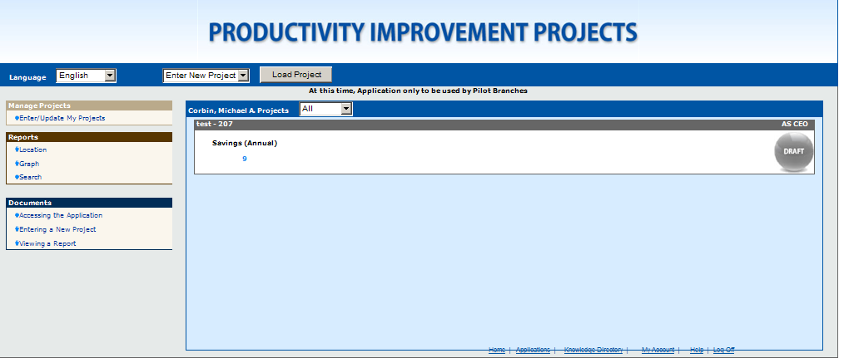
Figure 1

Enter/Update Page
The entry/update page (Figure 2) accepts all information for a project. When a project is in draft status only a Project Title is required to submit it. After Draft a Branch, Proecss, Short Desc, Detailed Desc, Savings Calc, and Savings (Annual) is required to save the project. After a project is out of draft status it is viewable through reports.

You always have access to update projects you entered; you can also give access to someone else to update the project by setting them as the project owner.

Switching the Currency drop down changes the currency the numbers on the page are displayed in. The amounts are converted using the web.pip_currency@plum table. All amounts are stored in the database as Euros.
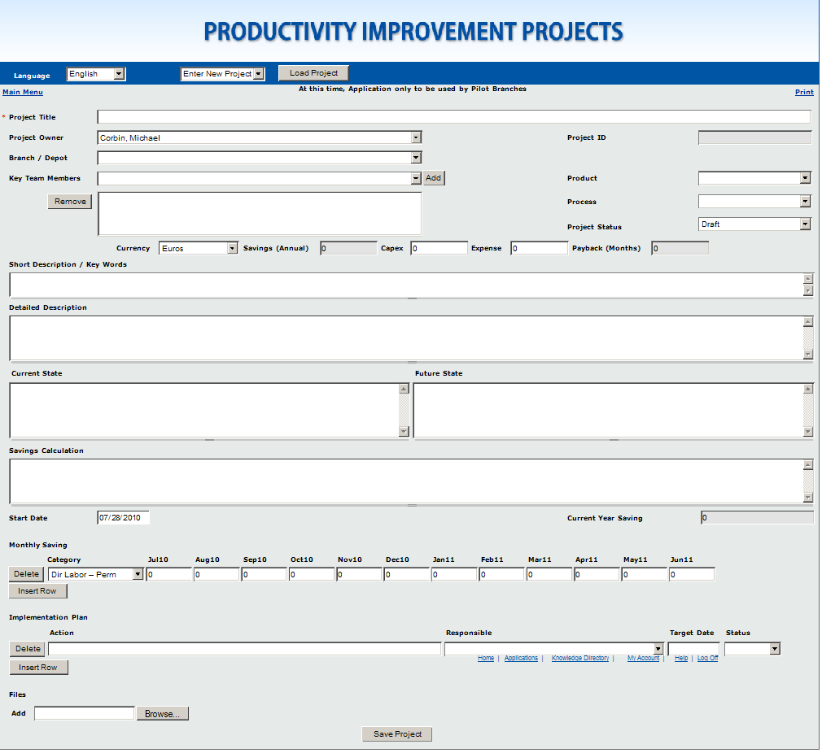
Figure 2

Location Report
The location report requires a year and currently to be selected before running. Once run it displays all projects entered for the selected parameters in a Late, On Plan, or Complete status. The link on the project title opens up the entry page for that project. If it is your project you can update or delete it, if not you can make a copy of the project.

All fields on the location report are directly off the entry page except for the Jan-Dec numbers and the Target Savings. The Jan-Dec numbers are a sum of all the Montly Savings entered for those months. The target savings are stored in the web.pip_branch_target@plum table. The itemid in that table links to the mart.mv_hfm_entity@rpt table.

The report can only be viewed a year at a time. If the Start Date for the project is not in January then the project will span 2 different years in the reports. In order to view all amounts entered for the project it needs to be run for both years.

Graph Report
The graph report displays the amounts from the location report in a bar graph. There is one bar for each month, and it splits each bar into a Late, On Plan, and Complete section. These sections represent the total Savings (Annual) for all the projects in those statuses. The target line displays the target for the selected location(s) broken up over 12 months.

Search Report

The search report is the same as the location report except it has more parameters, is not limited by status, and does not show the targets.

Database Additions/Changes

All tables are located in the web@plum scheme starting with a prefix of pip_ or v_pip_. This app also uses the view mart.v_hfm_pip_entity@rpt.world to display the location listing.

Audit Tables
none

Queries

